Lab 06 Conclusion
Resource Impact: Task Manager showed minimal CPU/memory change (Docker containers use ~50-100MB each). All containers cleaned up—back to baseline.

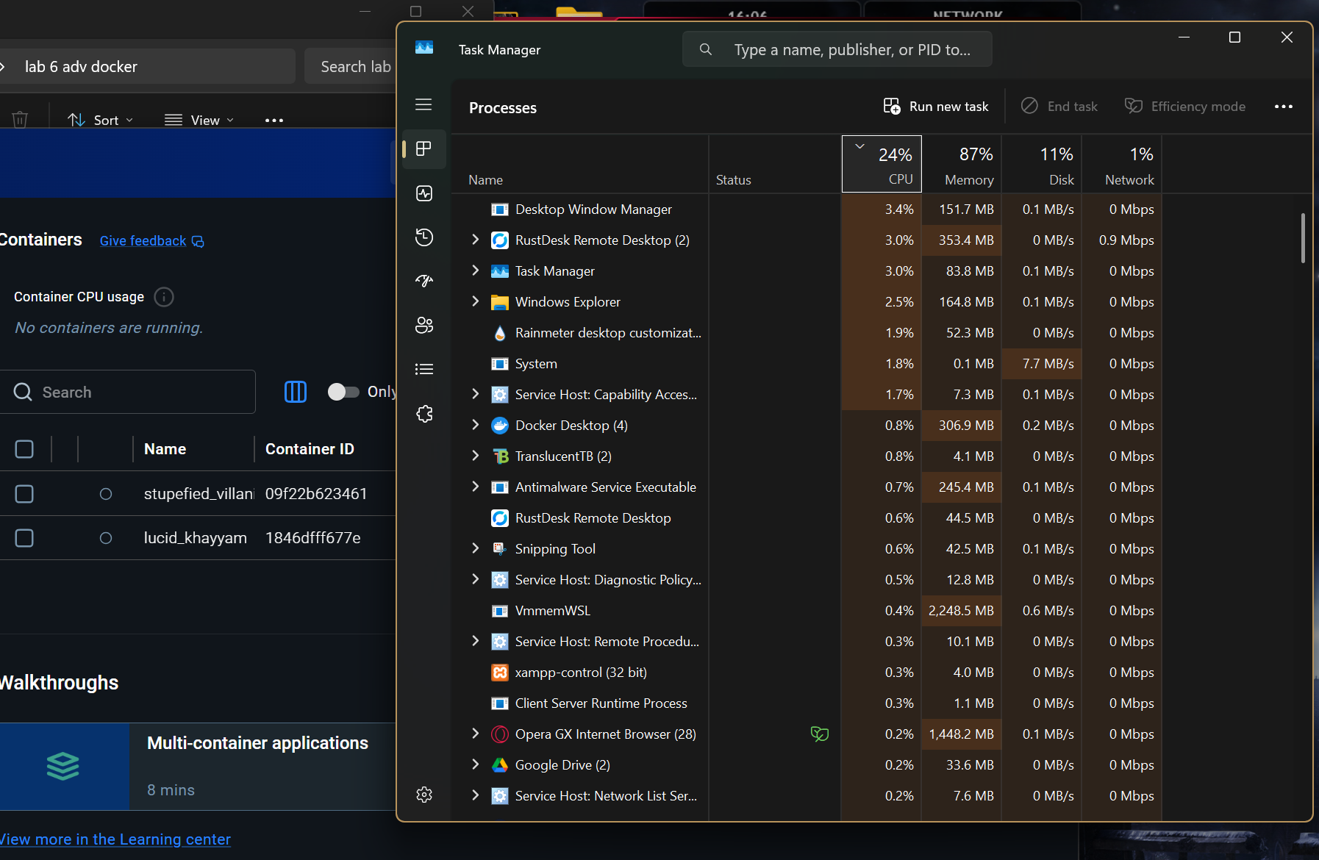
Port Publishing: Without -p, services inaccessible from browser (network isolation). http://localhost:8080 worked only after -p 8080:80. [Task A screenshot]

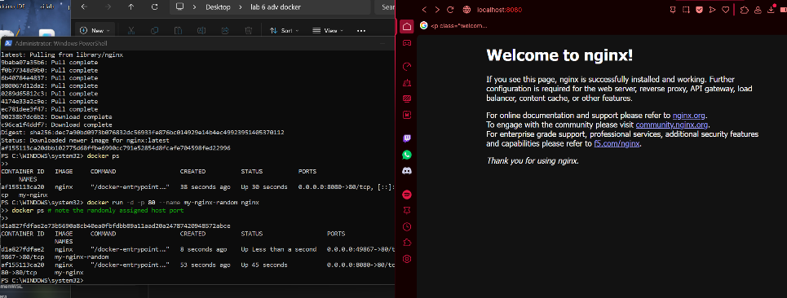
Data Persistence: Volumes needed for databases—without them, Postgres data lost on docker rm. Named volume survived container deletion: cat /app/data/test.txt showed "Lab 6 data saved!" [Task C screenshot]
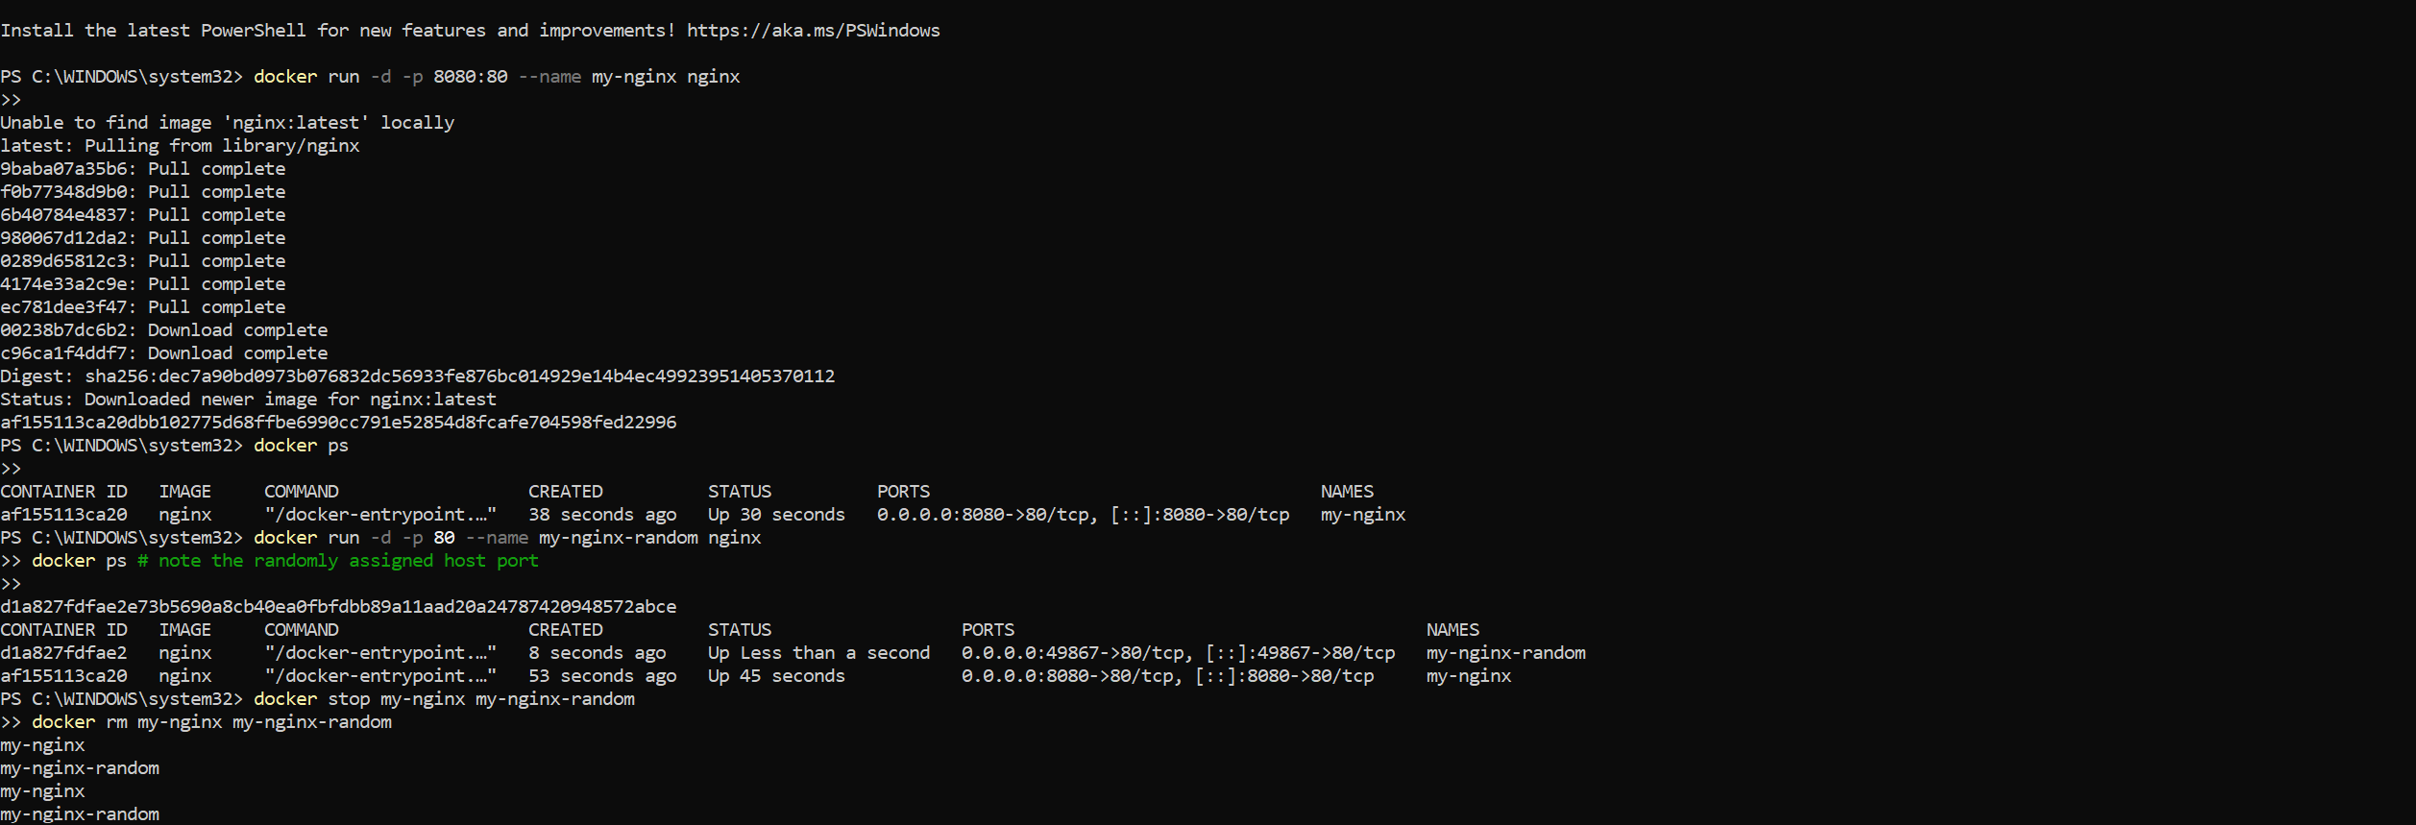
Bind Mount vs Volume:
- Bind mount (C:\lab6\site) for dev—live edit index.html, instant browser refresh.
- Named volume for prod data (Postgres)—managed by Docker, survives host changes. [Task D screenshot]

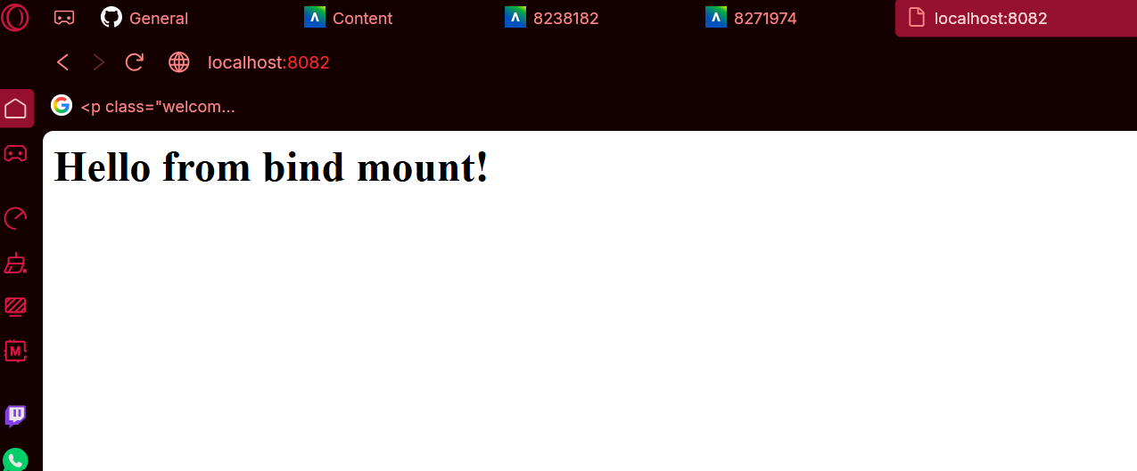
Compose Advantage: Single docker compose up -d starts nginx+postgres with networking/volumes vs 6+ manual docker run commands. docker compose ps confirmed both UP, localhost:8083 live. [Task E screenshot]
